**Steps to start or run the project :**

1. Install the Matlab 2010b.
2. After that unzip the file name **language_project_ml.zip**. And after unzipping open the directory (Where you unzip the file)in the matlab.

**Directory Structure after unzipping the file**

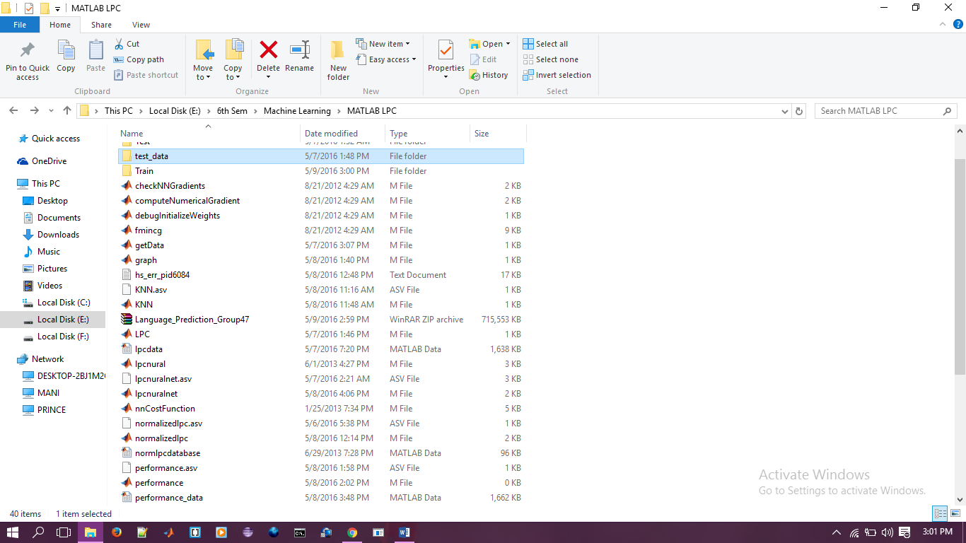

**Training Data:**

The Folder named **Train** in the above directory contains all the training data for every language for which we did this project.

**Testing Data:**

The Folder named **test_data** in the above directory contains all the testing data for every language for which we did this project.

1. In the matlab command window type **normalizedlpc.m (**This script file is used for the training of the data present at the folder location ‘**Train/../..’ ).**
2. The training will take approximate 9-10 hours after the training of the data, the output the training will stored in the file named **lpcdata.mat.**
3. After the training of the data we need to train our data using some machine learning algorithm for that we use **lpcnuralnet.m (**We have used neural network in our project **).**
4. After the 200 iteration, neural network gives us the value of the parameter **Theta1** and **Theta2.**
5. We need these parameter for the testing of our dataset.
6. After that now we can test our testing data using these parameter by neural network. After that run the file named **voicepredict.m (**This script used two machine learning approach for predicting the language first one is **neural network** and the second one is **K-NN ).**
7. After running the script this will predict the language of every test sample present at location ‘**test_data/…’**  .
8. After the prediction of all the test sample it will finally gives as the final confusion matrix as well as the accuracy of the system.